**Machine Learning Branches**

**Supervised Learning**: This method involves studying a group of examples to learn how to relate input data to predetermined targets.

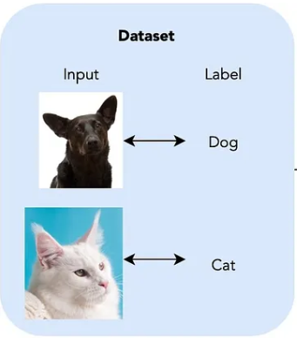

( classification , regression)

-> Scalar regression, binary classification, and multiclass classification are all included.

-> Sequence creation, syntax tree prediction, object detection, and image segmentation are a few unusual supervised learning subtypes.

* The majority of current deep learning applications fall into this category because it is the most prevalent type of machine learning.

**Unsupervised Learning:** Finding interesting modifications of input data without aims is the goal of unsupervised learning.

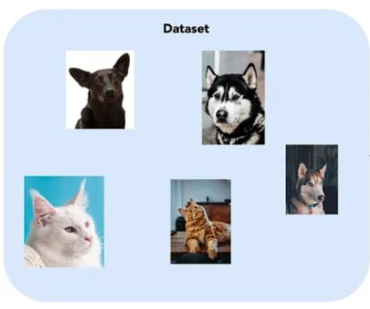

( clustering )

It is used for data denoising, compression, and visualization.

The categories of machine learning can cross over and exist as an undefined continuum. With a brief introduction to self-guided learning, this book mostly focuses on supervised learning.

It is used as a step to better understand a dataset before attempting to solve a supervised-learning problem.

Dimensionality reduction and clustering are well-known categories of unsupervised learning.

**Self-supervised Learning:** aparticular type of supervised learning, although it doesn't require human-annotated labels. Instead, a heuristic method is used to construct labels from the incoming data.

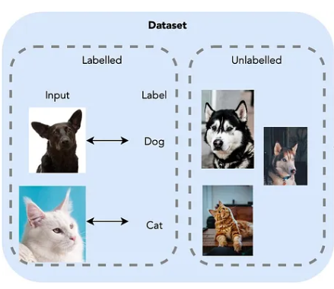

( classification regression )

Autoencoders, foretelling the next frame in a video, and guessing the next word in a text are a few examples of self-supervised learning. The distinction between supervised and unsupervised learning is hazy in this domain.

**Reinforcement learning**: The process of teaching an agent to make decisions to maximize a reward.

Although it has been very successful in video games, this field is still mostly one of study.

Self-driving cars, robotics, resource management, and education are just a few of the potential real-world uses for reinforcement learning.